KANBAN Methodology-

Kanban is a framework that falls under the Agile methodology. It was developed in the late 1940s by a Japanese engineer named Taiichi Ohno. Agile Kanban Framework focuses on visualizing the entire project on boards in order to increase [project transparency](https://kissflow.com/project/how-to-improve-project-transparency/) and collaboration between team members.

Kanban is one of the simplest frameworks used as it allows project managers to efficiently manage and keep track of their projects. A distinguishing feature of the Kanban framework among different [agile methodologies](https://kissflow.com/project/agile/agile-project-management-methodology/) is its compatibility with the existing organizational setting.

## How does Kanban work?

Kanban method revolves around the [kanban board](https://kissflow.com/project/agile/kanban-board-software/). It is a tool that visualizes the entire project to track the flow of their project. Through this graphical approach of Kanban boards, a new member or an external entity can understand what’s happening right now, tasks completed and future tasks.

**Kanban board indicates**

* the current tasks that are being performed
* the tasks to do in the future
* the tasks that are completed

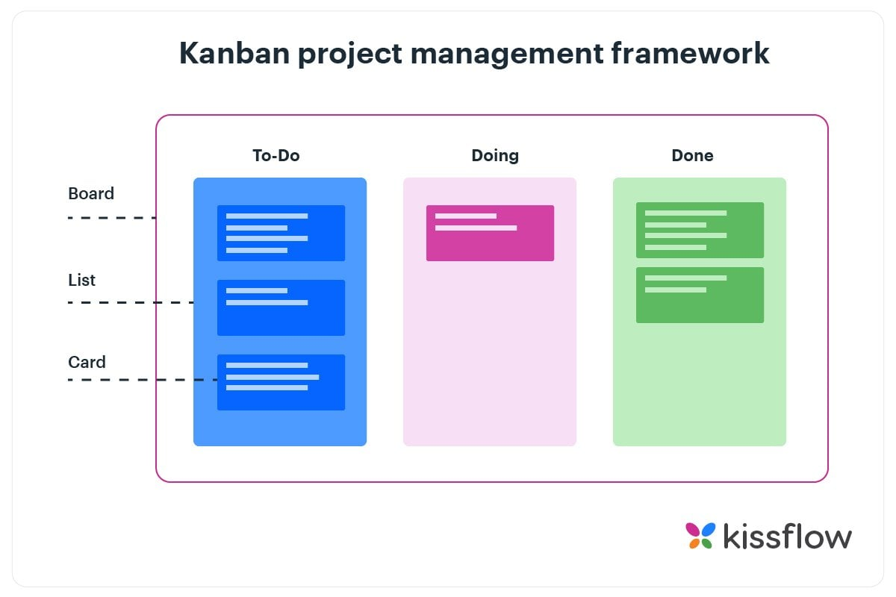

The divided columns are interconnected and tasks are gradually pulled from the leftmost column (future tasks) to the rightmost column (completed tasks). [Kanban system](https://kissflow.com/project/agile/effective-kanban-system/) measures the work cycle being completed through the principle of Work in Progress (WIP)*.* WIP has certain limits and a pre-defined specific status.

Limiting WIP in order to maintain consistent standards is one of the core principles that govern the Kanban methodology in Agile. It is extremely important for the team to complete the current tasks in the prescribed order.

## Kanban is a pull system

A pull system is a Lean technique that controls the flow of work by replacing what’s completed. A vending machine is a perfect example of a pull system–products will be restocked only when existing products have run out. Kanban precisely fits this definition.

Kanban is about work states unlike Scrum or Agile which focus on sprints and iterations. Kanban focuses on breaking down work into small tasks, visualizing them, and getting few items in any given work state. In the Kanban board, work always moves from left to right. And, you pick work from the column to your left when you have completed all your existing work items or when an urgent task surfaces. The [work-in-progress limits](https://kissflow.com/project/agile/wip-limits-in-kanban/) help you enforce this.